The Big Brancepeth Music Quiz - hope you enjoy it!

Just a few things to mention before you get started:
- The quiz is open to any individual, household or remote collaborating team!
- You can submit your answers anytime on or before Wednesday 3rd June (11:59pm!) to Richard Hardern: rdh2479@gmail.com - Winning Teams announced in Bugle that week!
- There are 4 rounds to the Quiz – maximum score of 70 marks
  - Round 1 - Modern Music (30 questions, each with 2 parts, ½ mark for each part, total = 30 marks)
  - Round 2 - Music Dingbats (10 questions, 1 mark each = 10 marks)
  - Round 3 - Pictures – Name the Musical (9 questions, 1 mark each = 12 marks)
  - Round 4 - Brancepeth’s Name that Tune (18 questions, 1 mark each = 18 marks)
- Fill in the grey answer boxes and you can either:
- print off this Quiz and fill it in by pen and when completed, photograph or scan the pages and email them to Richard.
- Alternatively, you can edit this document using your PC, tablet device or phone – save it and email it to Richard.
- REMEMBER - NO GOOGLING!! Please keep to the spirit of fair competition!

Team Name

Round 1 - Modern (mainly) Music - To see full size images and questions click the link https://spark.adobe.com/video/0htFI1NeSe8MT

No | Picture Aid | Question | Answers
 |  |  | Answer to Question | Name the Artist or Group
1 | 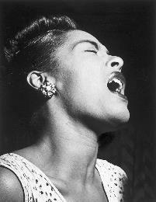 | What was the strange fruit about which she sang?
2 |  | What film theme song did she recently write and perform?
3 | 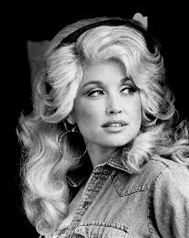 | What is the name of the theme park linked to her?
4 | 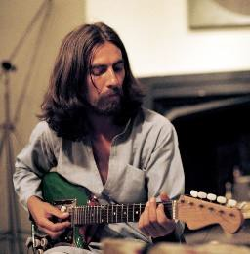 | Which country benefited from a charity concert he helped to organise in 1971

5 | 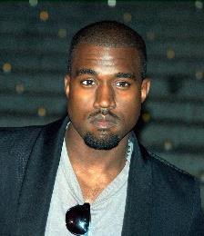 | He reached number 3 in the UK singles chart in 2015 with which other artists?
6 |  | Where was the group he was in established?
7 | 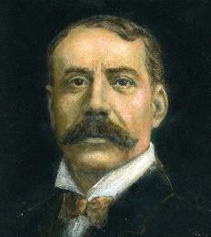 | Through/around which hills does the route named after him pass?
8 |  | After which famous singer songwriter is she said to be named
9 | 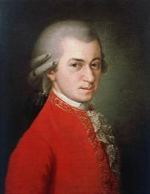 | Which instrument was magic in his opera?
10 |  | According to one of her most famous songs what can she not make you do?

11 | 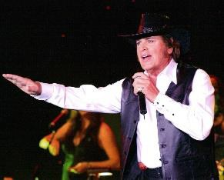 | What was his first UK number one single?
12 | 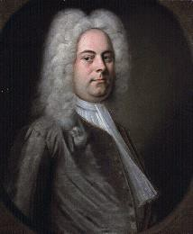 | What music did he compose that has been performed at British coronations for nearly 400 years?
13 |  | The title of her debut album is said to have been inspired by her university academic father. What was it?
14 | 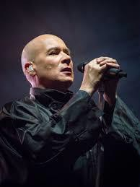 | The band he fronted released the 25th best ever selling single in the UK. What was the song’s title?
15 | 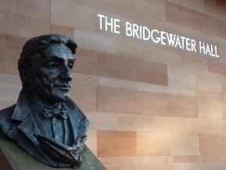 | With which orchestra is the man depicted in the sculpture most strongly associated?

16 | 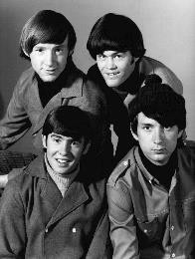 | What is the name of this group’s UK born lead singer?
17 |  | What was the title of his main group’s first chart single?
18 |  | Which 1960s non eponymous group was he a member of?
19 |  | With which bird did his group reach number 2 in the UK singles chart?
20 | 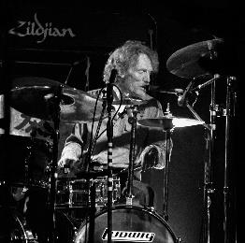 | With which dairy product is he associated?
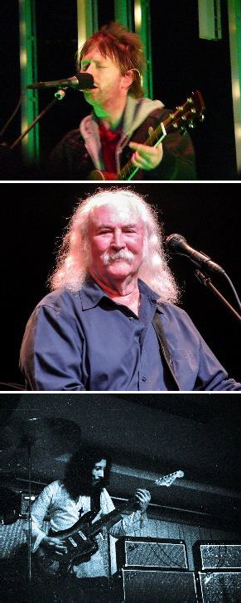

21 |  | In which crime drama, set in Hackney, does she act?
22 | 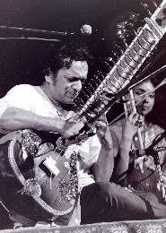 | What instrument is he famous for playing?
23 |  | What was the name of his solo UK number 1 single?
24 | 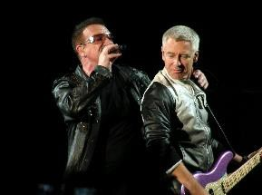 | What is the stage name of this band’s lead guitarist?
25 | 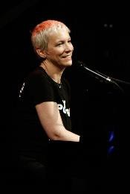 | Who was her Sunderland born musical partner?

26 |  | What was the name of her controversial book published in 1982?
27 | 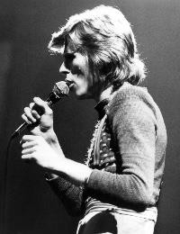 | What was his real name?
28 | 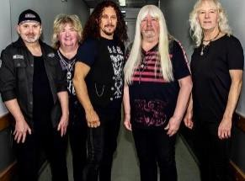 | According to this group what happened in the ballroom?
29 |  | Where does she come from?
30 | 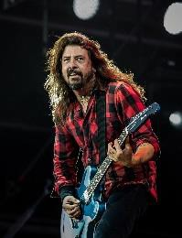 | What are the two most famous bands he is or has been in?

Round 2 - Musical ‘Singles’ Dingbats!
No video this time – just simply solve the dingbats below (All hit ‘Singles’ between 1950s-1990s)

Tiger | Not Not  Hard Dead | Sedimentary Metamorphic Igneous  Sedimentary | Over ROYGBIV
1. | 2. | 3 | 4
ON ON  ROAD ROAD | Apache v  Comanche | Running tap to the toilet | XXV, or VI to IV
5. | 6. | 7. | 8.
Lower Lower Lower | Silence Please be quiet  Shush Shut up
9. | 10.

- Identify famous west end musicals from the pictures below:
Round 3 - Name the Musical

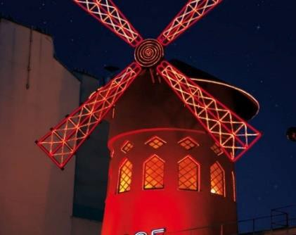 | 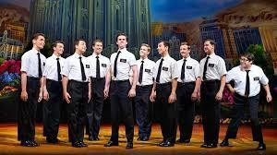 |  | 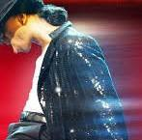
1. | 2. | 3. | 4.
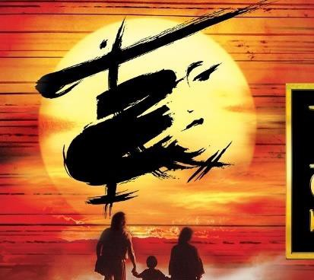 | 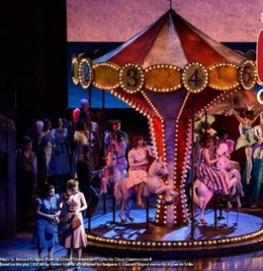 | 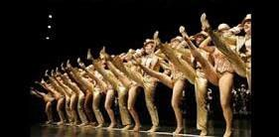 | 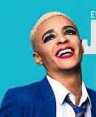
5. | 6. | 7. | 8.
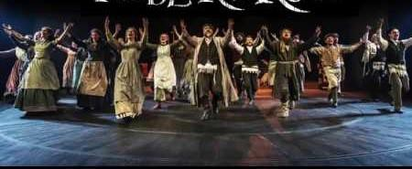 | 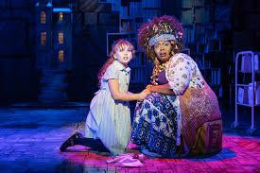 | 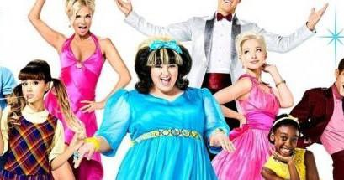 | 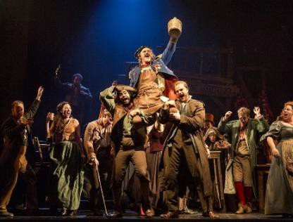
9. | 10. | 11. | 12.

Round 4 - Brancepeth’s Got Talent – Name that Tune! – to answer the questions click this link (you can pause and replay the video as much as you want!) https://youtu.be/yCysyFe56dk

No | Question | Answer
1 | Name the song
2 | Name the album it is from
3 | Name the film in which this tune is featured
4 | What is the song title?
5 | This song is the theme to which movie?
6 | Which band sang it?
7 | What is the name of this classic tune?
8 | What is the music about?

9 | What is the film title?
10 | Name the composer
11 | What James Bond move is theme tune from?
12 | Which actor starred in the 1967 version of this film?
13 | Which musical is this song from?
14 | Which TV presenter released this song as a single?
15 | What is the name of the film which shares its title with this music?
16 | Name the composer
17 | What musical film is this song from?
18 | What year was this film released?

You can submit your answers anytime
on or before Wednesday 3rd June (11:59pm)

THE END – well done!

to rdh2479@gmail.com

