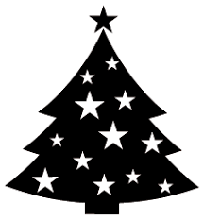
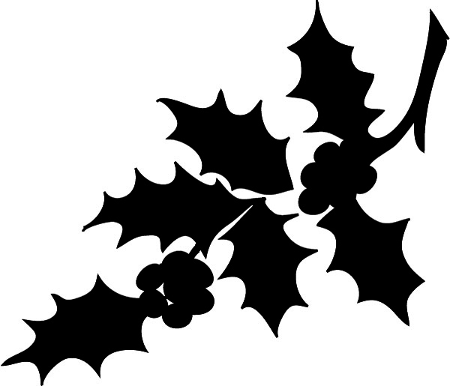
The Brancepeth 2020 Xmas Quiz …ho. ho. ho

£2 per team entry fee
1st, 2nd & 3rd Team prizes

- The quiz is open to any individual, household or collaborating team!
- You can submit your answers anytime on or before 14 December (11:59pm!)
- Please pop your £2 entry fee into the Village Hall postbox – thank you
- There are 2 rounds to the quiz (Round 1 & Rounds 2, a-e)
- You can either:
  - Populate your answers in the boxes below using your computer or tablet device and return your answers to: BrancepethCA@gmail.com - or,
  - print a copy of this quiz document and post your answers through the village hall letterbox
- REMEMBER - NO GOOGLING!! Please keep to the spirit of fair competition!

Team Name
Email (preferable) or other contact details

***************************************************************************************************************
Round 1 – General Knowledge

1 | What was first introduced by the march "Liberty Bell" in October 1969?
2 | Name the three orange coloured properties on the UK version of Monopoly
3 | What kind of animal was Mrs Tiggywinkle?
4 | Which three countries have both an Atlantic and a Mediterranean coastline?
5 | What wonder horse had its own TV series in the 1950s?
6 | What is the symbol for the element potassium?
7 | What is the southernmost capital city....
8 | ....and what is the northernmost?
9 | What term both describes perfect vision and a form of the game of cricket?
10 | Which chain of restaurants is named after a character from the novel Moby Dick?
11 | In which league do Spennymoor Town currently play?
12 | What does a numismatist collect?
13 | Which car manufacturer produced the Anglia?
14 | What bird can swim but not fly?
15 | Who preceded Neil Kinnock as leader of the Labour Party?

Round 2 – Seasonal (parts a, b, c, d & e)

a) General
1 | There are two Christmas Islands - in which oceans are they?
2 | The Christmas tree in Trafalgar Square, London is a gift from which nation?
3 | What Christmas item was invented by London baker Tom Smith in 1847?
4 | Stel (Dingbat)
5 | What is the name of The Simpson's pet greyhound?
6 | What is the plant "Viscum Album" better known as?
7 | Who wrote the song "White Christmas"?
8 | In which film did Judy Garland sing "Have Yourself a Merry Little Christmas"?
9 | What name is given to the four-week period leading up to Christmas?
10 | Name the three reindeer whose name begins with the letter 'D'?

b) Music
1 | Which composer born in Hamburg wrote the music for Hark The Herald Angels Sing? | 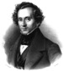
2 | Which composer, born in 1685, wrote the Christmas Oratorio? | 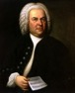
3 | Also born in 1685, he wrote The Messiah | 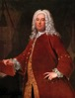
4 | Who wrote The Nutcracker ballet? | 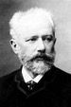
5 | Who conducts the Cambridge Singers?
6 | Which female artist Rocked Around The Christmas Tree? | 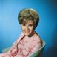
7 | How many miles did The Pretenders Travel?
8 | Where was the fairytale of The Pogues and Kirsty McColl? | 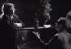
9 | Which band wished it could be Christmas every day?
10 | Which band Rang Out Solstice Bells in 1976? | 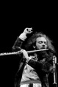

c) Entertainment
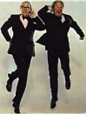 | 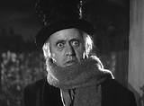 | 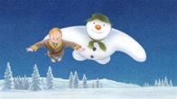
1 Their names | 2 Film title and actor’s name | 3 Who wrote it?
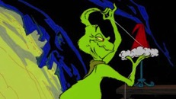 | 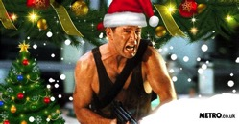 | 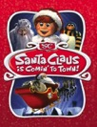
4 Who is it and what did he steal? | 5 Film title and actor’s name | 6 Who narrates the1970 film of this title
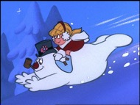 | 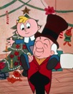 | 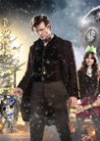
7 Name of the snowman | 8 Name of the man in the hat | 9 Who is the male character
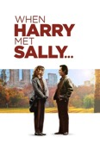
10 Male and female lead actors

d) Carols - From which carol are the following lines taken?
1 | While mortals sleep, the angels keep....
2 | And his cradle was a stall
3 | And take us to Heaven to live with us there
4 | Sing all ye citizens of Heaven above
5 | ....and the running of the deer....

e) Cryptic - All except numbers 9 and 10 are one word answers with a festive connection
1 | Biscuits are bananas for these party pieces
2 | In this town, she has the French edge
3 | Man with stick disliked children
4 | Bird only has some crest
5 | This animal sounds like it’s wet, love
6 | Don’t let this pulverise you....
7 | ....and this conveyance sounds like a killer!
8 | Does this saint scratch?
9 | This room doesn’t rock
10 | These people might have come from Leyton

The End

Wishing you all a safe and happy Christmas

This quiz was kindly created by Peter Hodge. Thank you, Peter!

